1.For different categories of acquirers, what is the average number of months since the inception of the acquired company after which they are acquired.

**SELECT**

**acquirer_category_code,**

**ROUND(**

**avg(**

**cast(**

**cast(acquired_at AS date) - cast(founded_at AS date) AS int**

**) / 30**

**),**

**0**

**) AS average_number_of_months**

**FROM**

**tutorial.crunchbase_acquisitions A**

**JOIN tutorial.crunchbase_companies C ON A.acquirer_name = C.name**

**GROUP BY**

**acquirer_category_code**

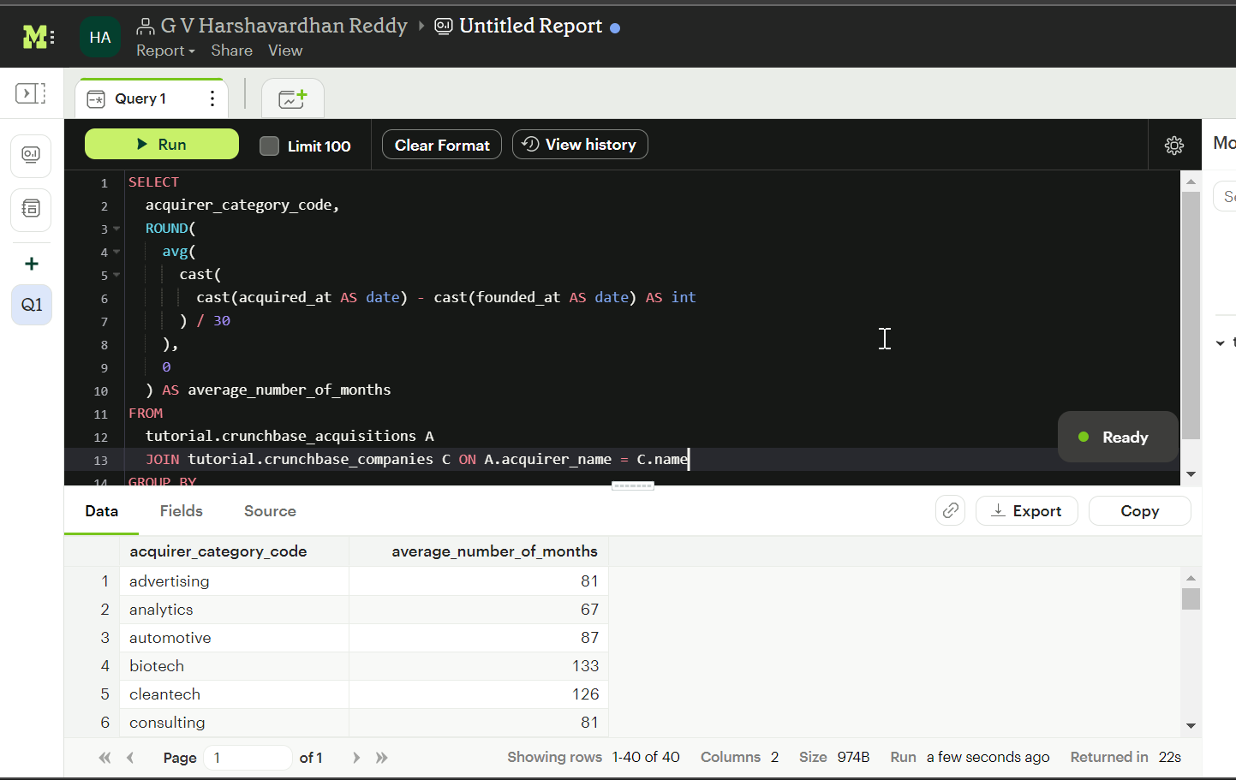

2.Is there any trend for quarters when more companies are acquired

**SELECT**

**RIGHT(acquired_quarter, 2) AS quarter,**

**count(acquirer_name) AS no_of_acquired_companies**

**FROM**

**crunchbase.acquisitions**

**GROUP BY**

**quarter**

**ORDER BY**

**1**

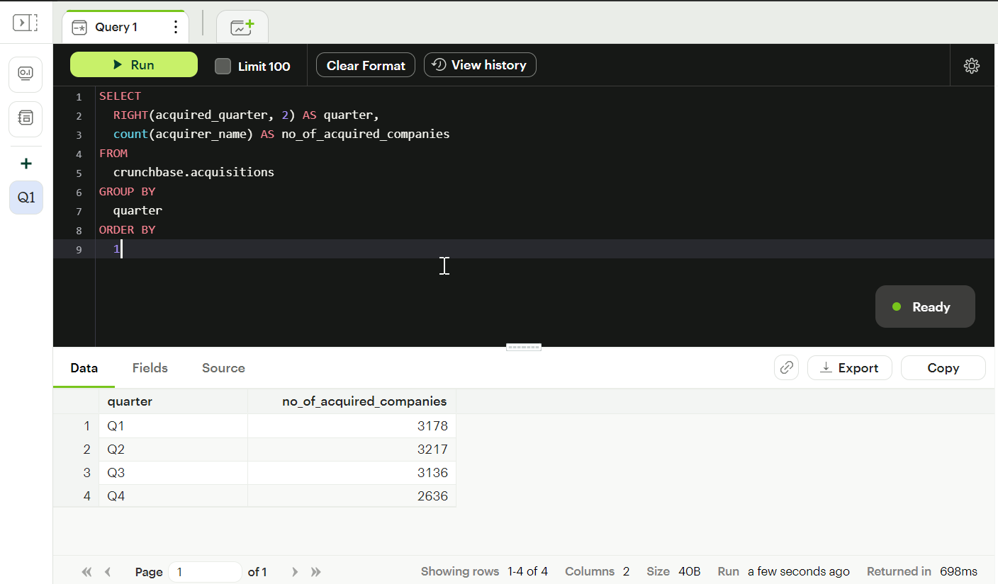

3.For each company_category_code identify the average raised_amount_usd per quarter

**SELECT**

**company_category_code,**

**RIGHT(funded_quarter,2) as quarter,**

**AVG(raised_amount_usd) AS average_raised_amount**

**FROM**

**tutorial.crunchbase_investments**

**WHERE**

**raised_amount_usd IS NOT NULL**

**GROUP BY**

**company_category_code,**

**quarter**

**ORDER BY**

**1,**

**2**

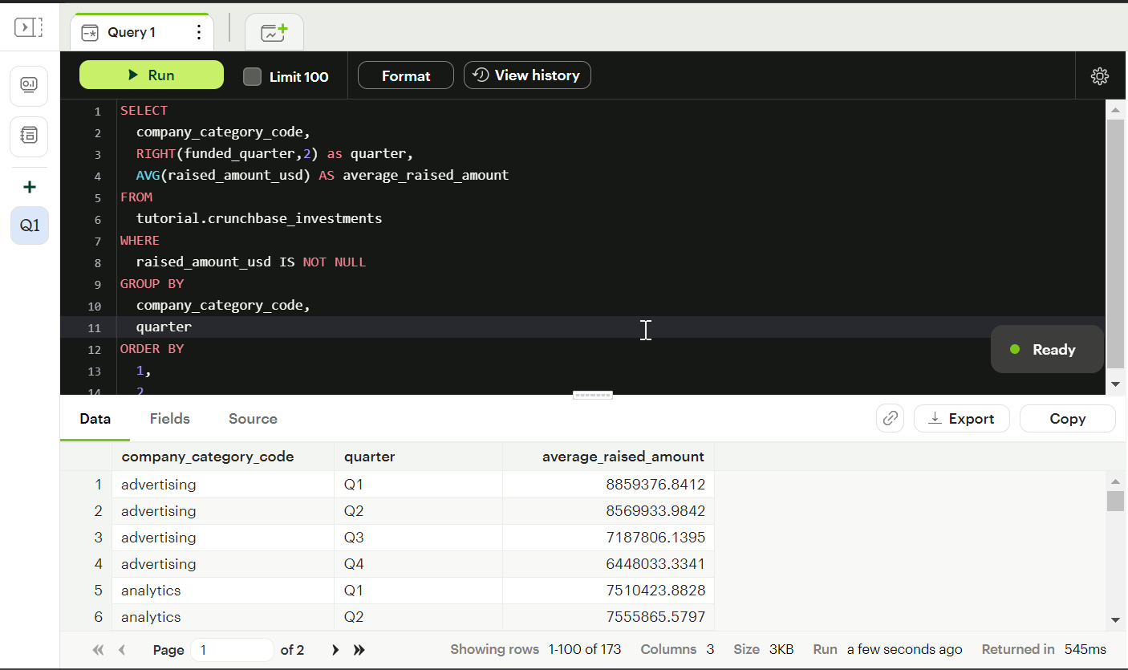

4.Which investor (company ) is more likely to invest in USA based companies?

**SELECT**

**investor_name,**

**COUNT(company_name)**

**FROM**

**tutorial.crunchbase_investments**

**where company_country_code='USA'**

**GROUP BY**

**investor_name**

**ORDER BY**

**2 DESC,**

**1** 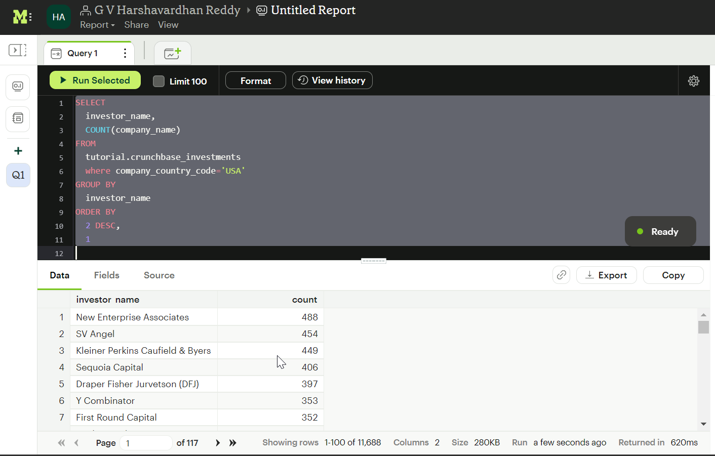

5.For different type of funding rounds, what is the average raised amount per quarter

**SELECT**

**funding_round_type,**

**RIGHT(funded_quarter, 2) AS quarter,**

**AVG(raised_amount_usd) AS average_amount_raised**

**FROM**

**tutorial.crunchbase_investments**

**WHERE**

**raised_amount_usd IS NOT NULL**

**GROUP BY**

**funding_round_type,**

**quarter**

**ORDER BY**

**1,**

**2**

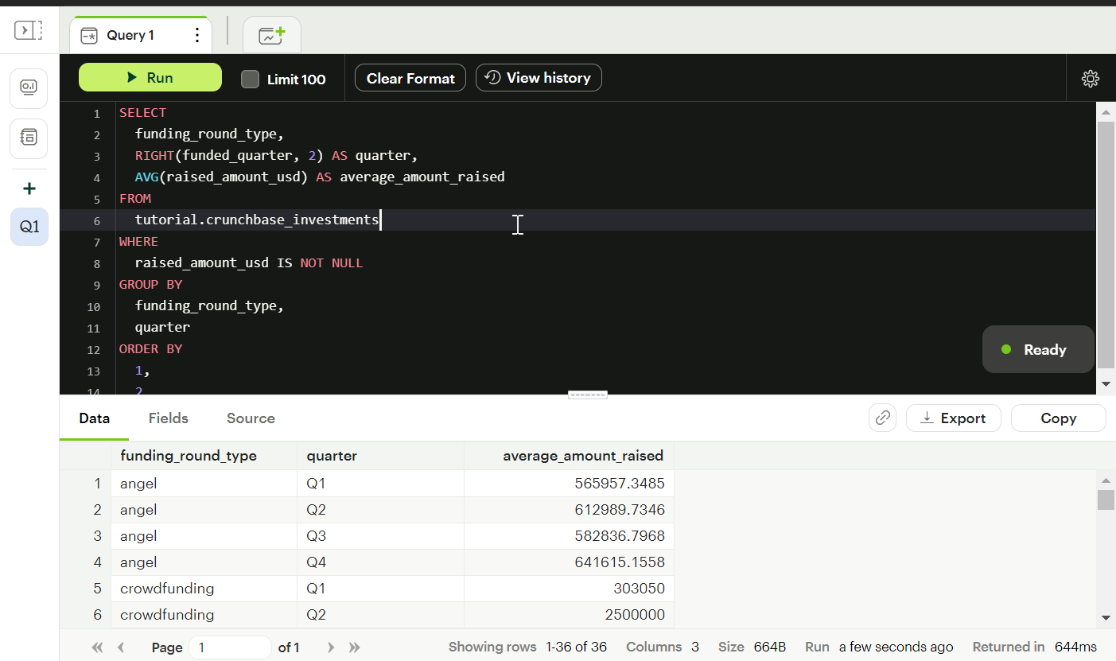

6.Identify companies that received an investment from Japan following an investment from Great Britain where investor is finance category company

**SELECT**

**A.company_name**

**FROM**

**(**

**SELECT**

**company_name,**

**investor_country_code,**

**lead(investor_country_code) over(**

**ORDER BY**

**funded_at**

**) AS next_investor_company**

**FROM**

**tutorial.crunchbase_investments**

**WHERE**

**investor_category_code = 'finance'**

**) A**

**WHERE**

**A.next_investor_company = 'GBR'**

7.Out  of all 'operating' status companies, which category of companies have the highest average funding_total_usd?

**SELECT**

**category_code,**

**AVG(funding_total_usd) AS average_funds_raised**

**FROM**

**tutorial.crunchbase_companies**

**WHERE**

**STATUS = 'operating'**

**AND funding_total_usd IS NOT NULL**

**GROUP BY**

**category_code**

**ORDER BY**

**2 DESC**

**LIMIT**

8.For each category, what percent of companies received funding within 3 years of their founding?

SELECT

category_code,

(

COUNT(

CASE

WHEN (

cast(

date_Part('year', cast(first_funding_at AS date)) - date_part('year', cast(founded_at AS date)) AS int

)

) <= 3 THEN TRUE

ELSE NULL

END

) * 100

) / count(*) AS percentage_of_companies_which_received_funding_in_less_than_3years

FROM

tutorial.crunchbase_companies

GROUP BY

category_code

ORDER BY

1. DESC

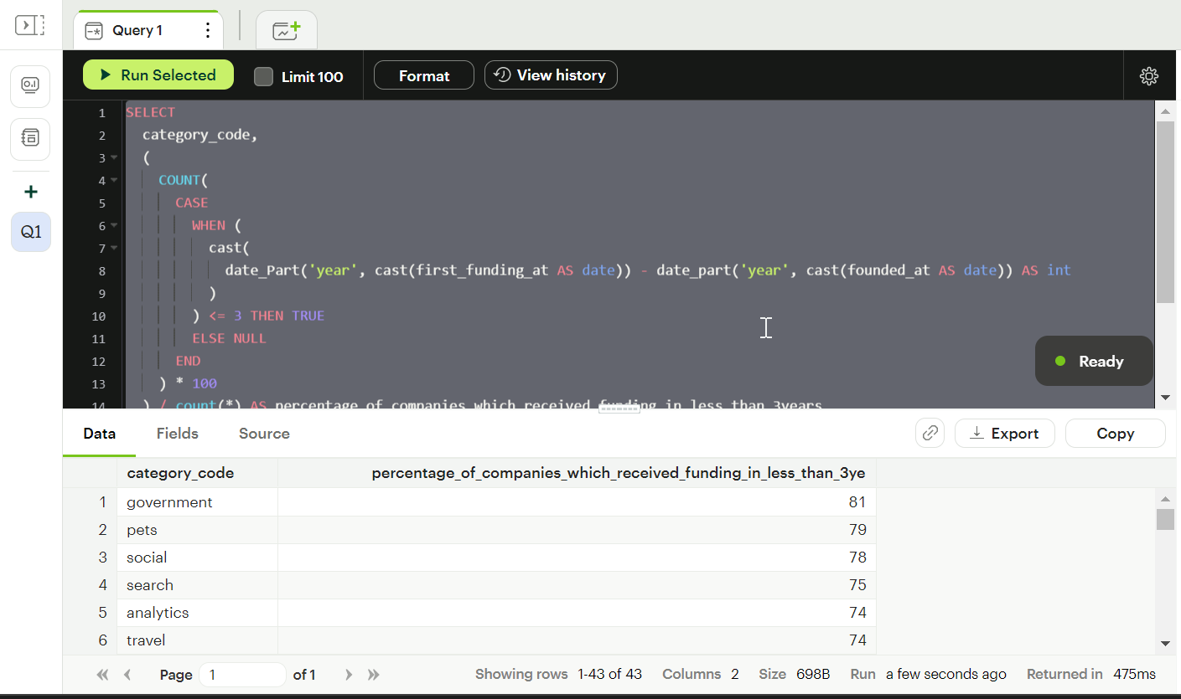

9.Clean the 'last_funding_at' column (convert it to time stamp) and get the time difference with the current time.

**SELECT**

**NOW() - cast(last_funding_at AS timestamp) AS year**

**FROM**

**tutorial.crunchbase_companies**

